<https://www.youtube.com/watch?v=fJaKO8FbDdo&list=PLgUwDviBIf0pwFf-BnpkXxs0Ra0eU2sJY&index=15>

NOTE : Remember that only the count has been asked and not to actually solve the strings.



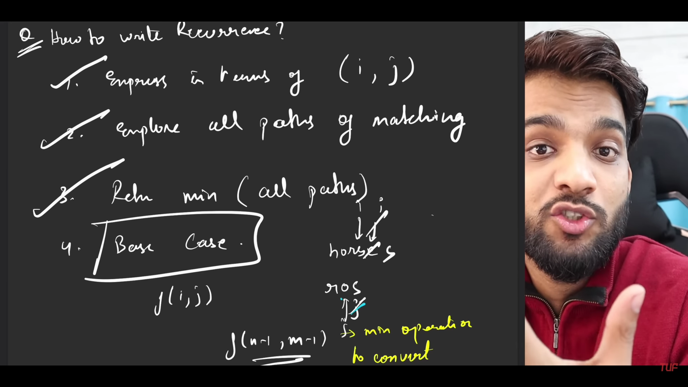

Write all the possibilities (complete first 3 steps)

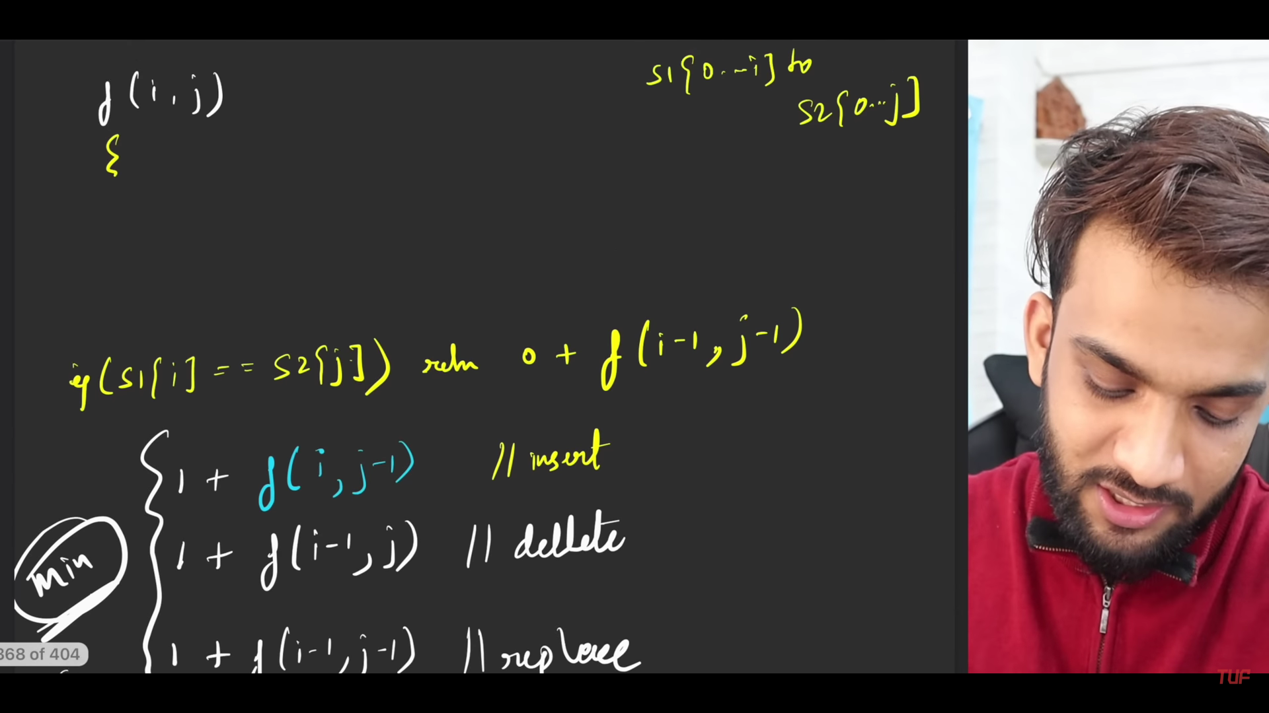

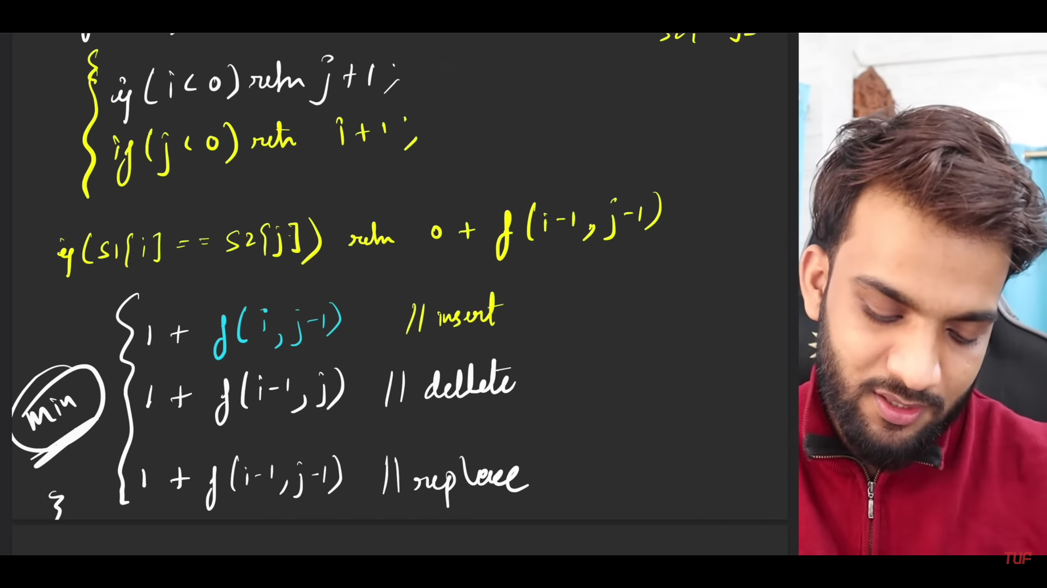

Base Case logic :-

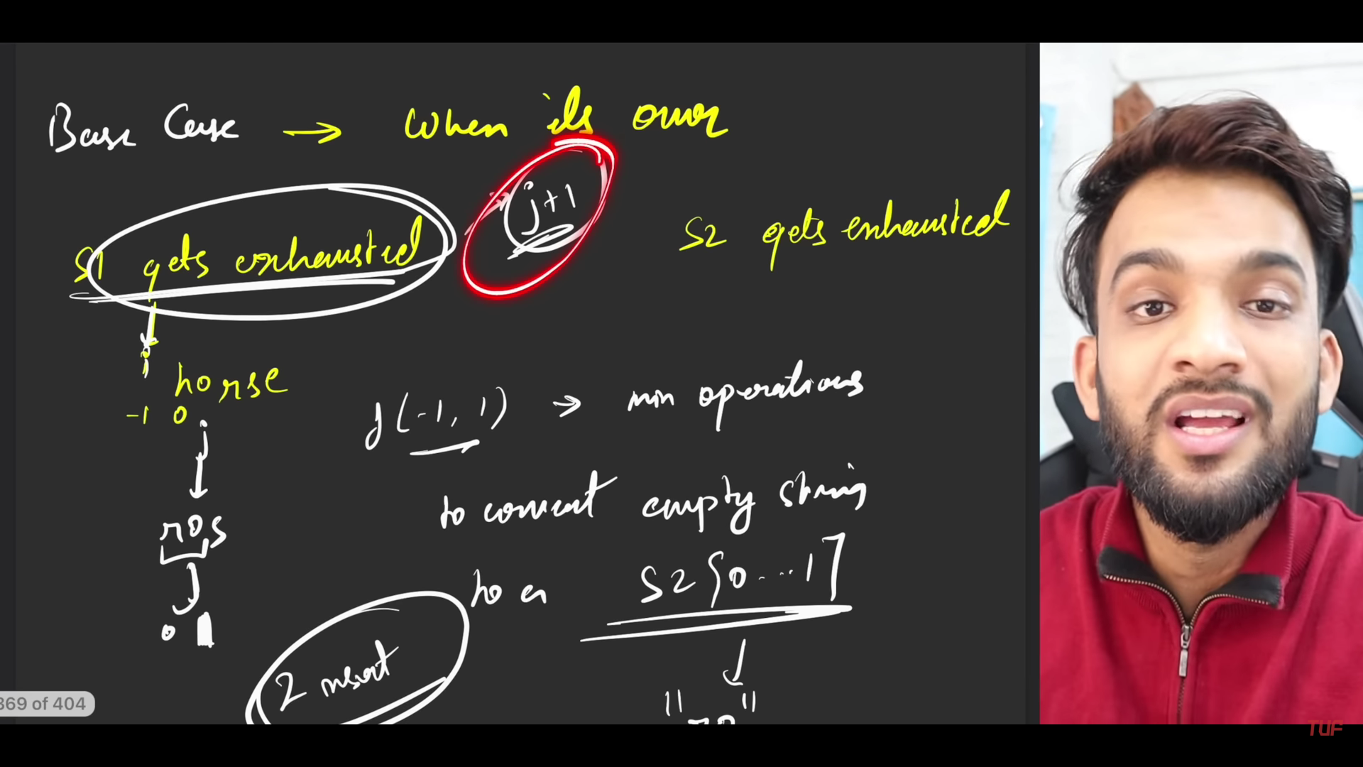

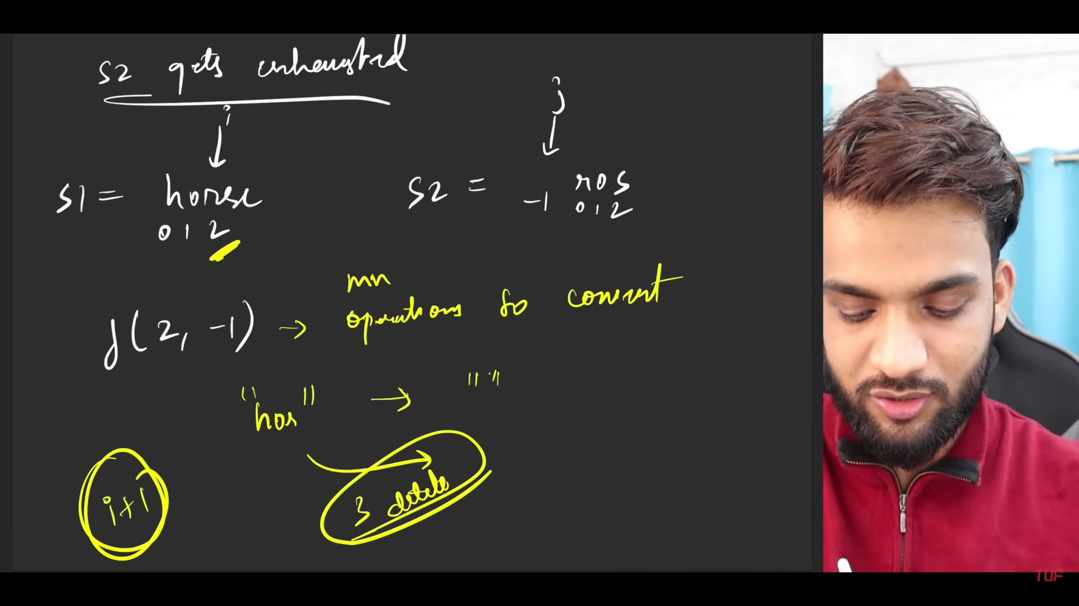

Time Comp : Exponential (2^n or 2^m)

Space Comp: O(N x M)

* Tabulation

